EXERCISE 6.2

Patrick Weatherford

Last modified: 06 October 2021

### Markdown Basics

#### Favorite Foods

1. Pizza
2. Brisket
3. Wings

#### Images

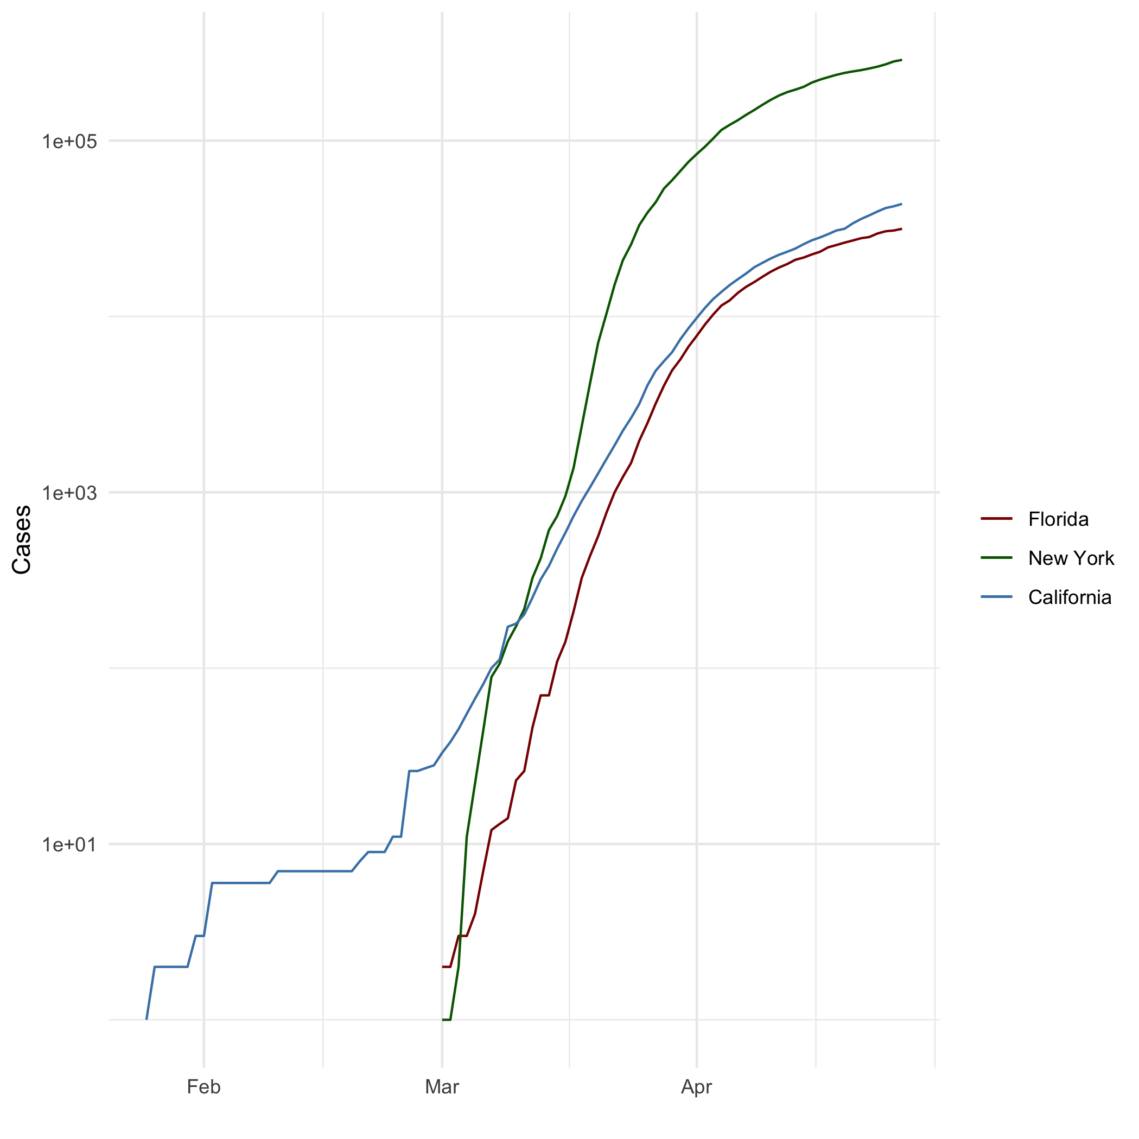

#### Add a Quote

*“I’m a great believer in luck, and I find the harder I work, the more of it I have.”*

#### Add an Equation

**Sample Standard Deviation**: $s=\frac{\sqrt{∑(x-\overset{‾}{x})^{2}}}{n-1}$

#### Add a Footnote

Blah blah blah.[1]

#### Add Citations

* R for Everyone (Lander 2014)
* Discovering Statistics Using R (Field et al.2012)

### Inline Code

#### NY Times COVID-19 Data

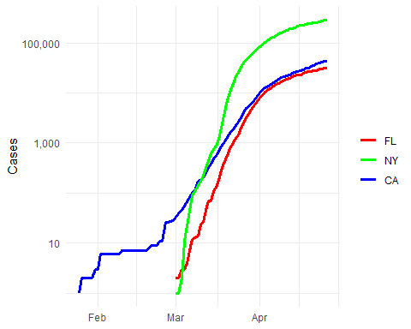

#### R4DS Height vs Earnings

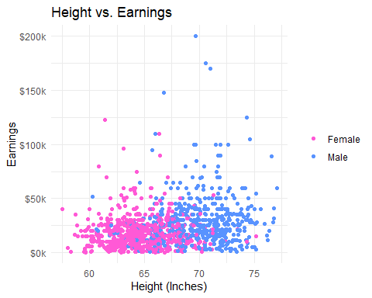

### Tables

#### Knitr Table with Kable

knitr::kable(characters_df, caption="One Ring to Rule Them All")

One Ring to Rule Them All

|  |  |  |  |  |
| --- | --- | --- | --- | --- |
| name | race | in_fellowship | ring_bearer | age |
| Aragon | Men | TRUE | FALSE | 88 |
| Bilbo | Hobbit | FALSE | TRUE | 129 |
| Frodo | Hobbit | TRUE | TRUE | 51 |
| Galadriel | Elf | FALSE | FALSE | 7000 |
| Sam | Hobbit | TRUE | TRUE | 36 |
| Gandalf | Maia | TRUE | TRUE | 2019 |
| Legolas | Elf | TRUE | FALSE | 2931 |
| Sauron | Maia | FALSE | TRUE | 7052 |
| Gollum | Hobbit | FALSE | TRUE | 589 |

#### Pandoc Table

|  |  |  |  |  |
| --- | --- | --- | --- | --- |
| Name | Race | In Fellowship? | Is Ring Bearer? | Age |
| Aragon | Men | Yes | No | 88 |
| Bilbo | Hobbit | No | Yes | 129 |
| Frodo | Hobbit | Yes | Yes | 51 |
| Sam | Hobbit | Yes | Yes | 36 |
| Sauron | Maia | No | Yes | 7052 |

### References

Lander (2014) Field, Miles, and Field (2012)

Field, A., J. Miles, and Z. Field. 2012. *Discovering Statistics Using r*. SAGE Publications. <https://books.google.com/books?id=wd2K2zC3swIC>.

Lander, J. P. 2014. *R for Everyone: Advanced Analytics and Graphics*. Addison-Wesley Data and Analytics Series. Addison-Wesley. <https://books.google.com/books?id=3eBVAgAAQBAJ>.

1. Footnote about blah blah blah